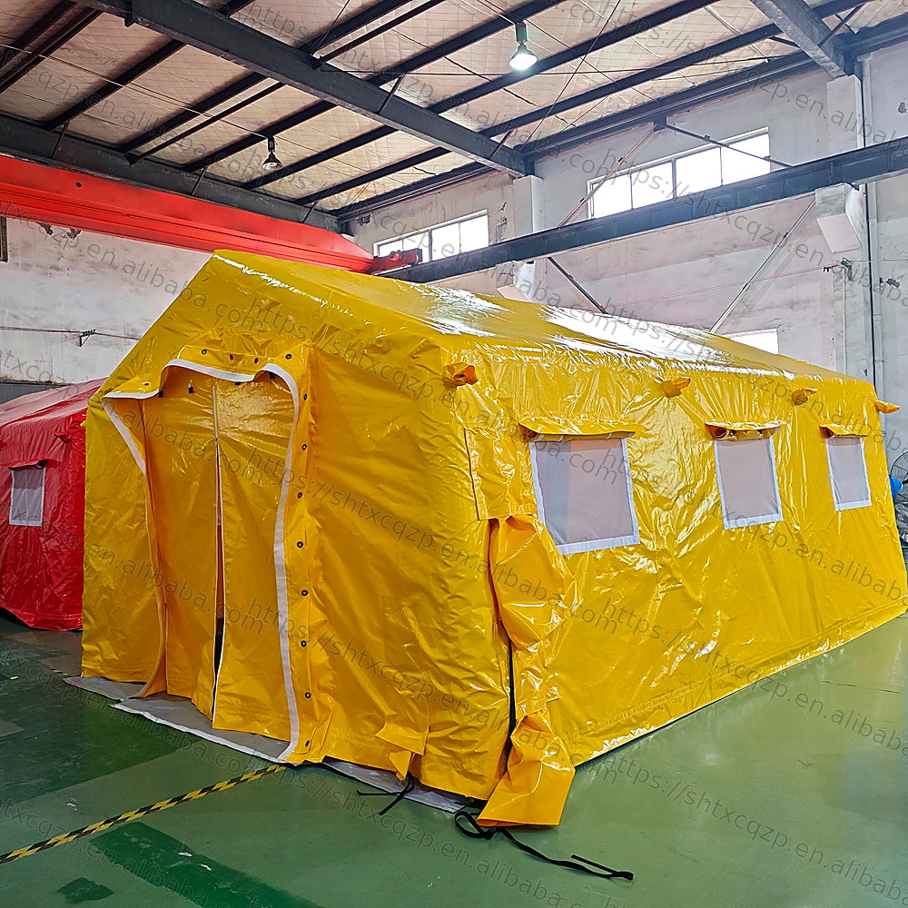 | Custom Inflatable Medical Tent  Rapid Deployment | Emergency Medical Support | Field Hospital | Temporary Treatment Area  A professional inflatable medical shelter designed for emergency rescue, temporary healthcare stations, triage zones, disaster relief, first-aid command centers, quarantine support and outdoor medical operations.

1. Product Overview
This inflatable medical tent uses a strong air-beam structure with a durable yellow outer cover, grey internal inflatable frame, transparent mesh windows, roll-up ventilation covers and reinforced entrance doors. The design supports fast setup, convenient transportation, reliable weather protection and flexible customization for different medical and emergency scenarios.
Item | Description
Product Name | 6x4x3m Inflatable Medical Tent / Emergency Medical Tent / Field Hospital Tent
Structure | Inflatable air-beam frame with protective outer tarpaulin cover
Color | Yellow sample shown; custom colors available
Material Options | High-strength PVC tarpaulin, TPU or customized commercial-grade inflatable fabric
Windows | Transparent mesh windows with roll-up covers for ventilation and daylight
Doors | Reinforced entrance with zipper, hook-and-loop fastener, button and cover flap options
Accessories | Air blower, repair kit, storage bag, anchoring ropes, ground pegs and optional lighting/partition systems
Customization | Size, color, logo printing, window layout, door quantity, inner partitions and functional zones can be customized

2. Product Photo Gallery
01 Main View | 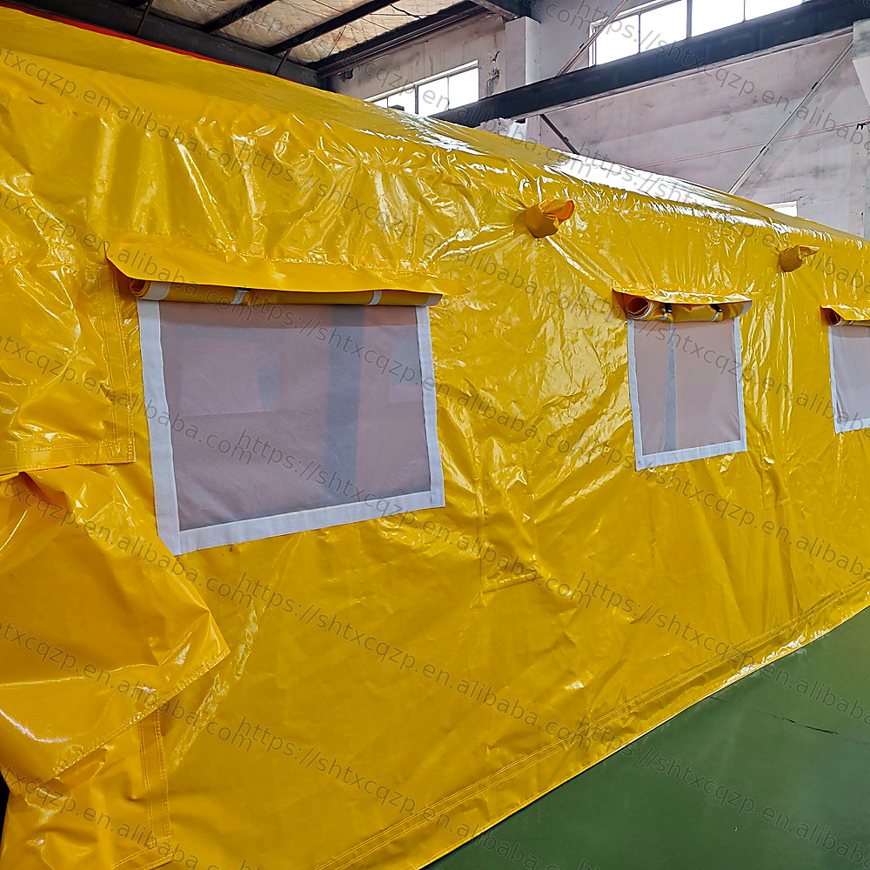  02 Side Windows

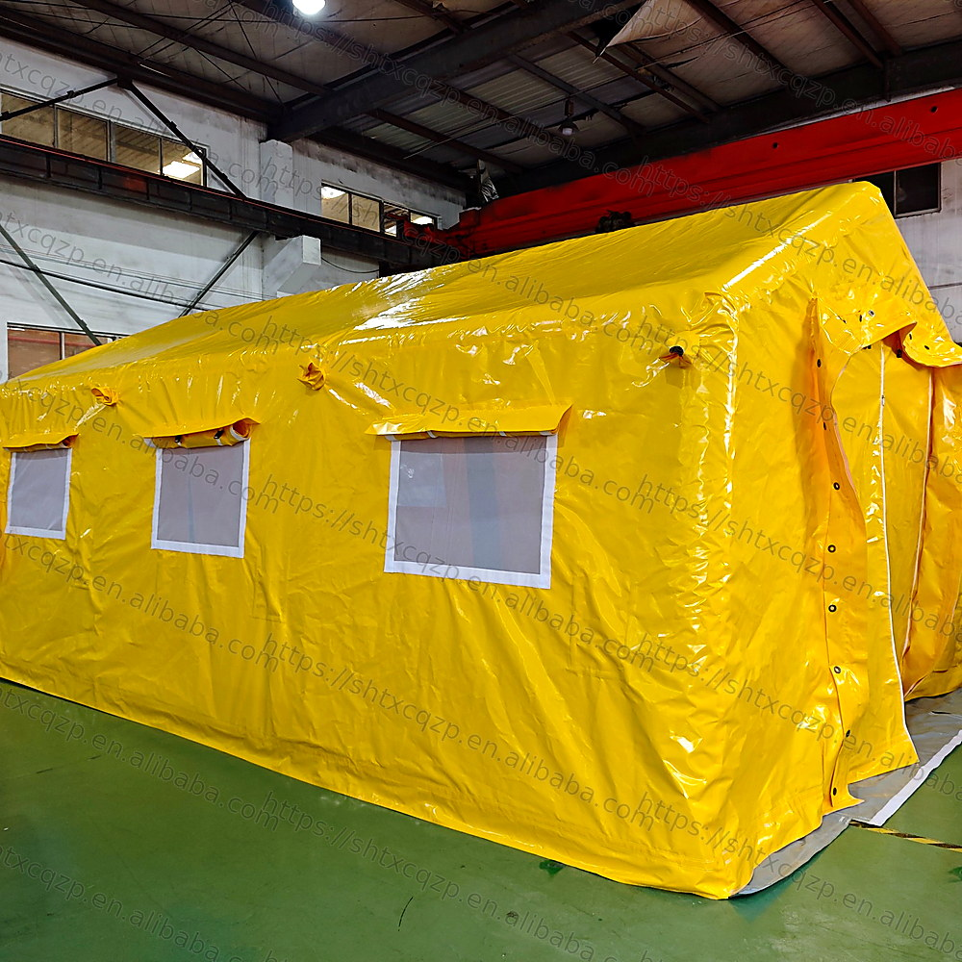  03 Side Door View | 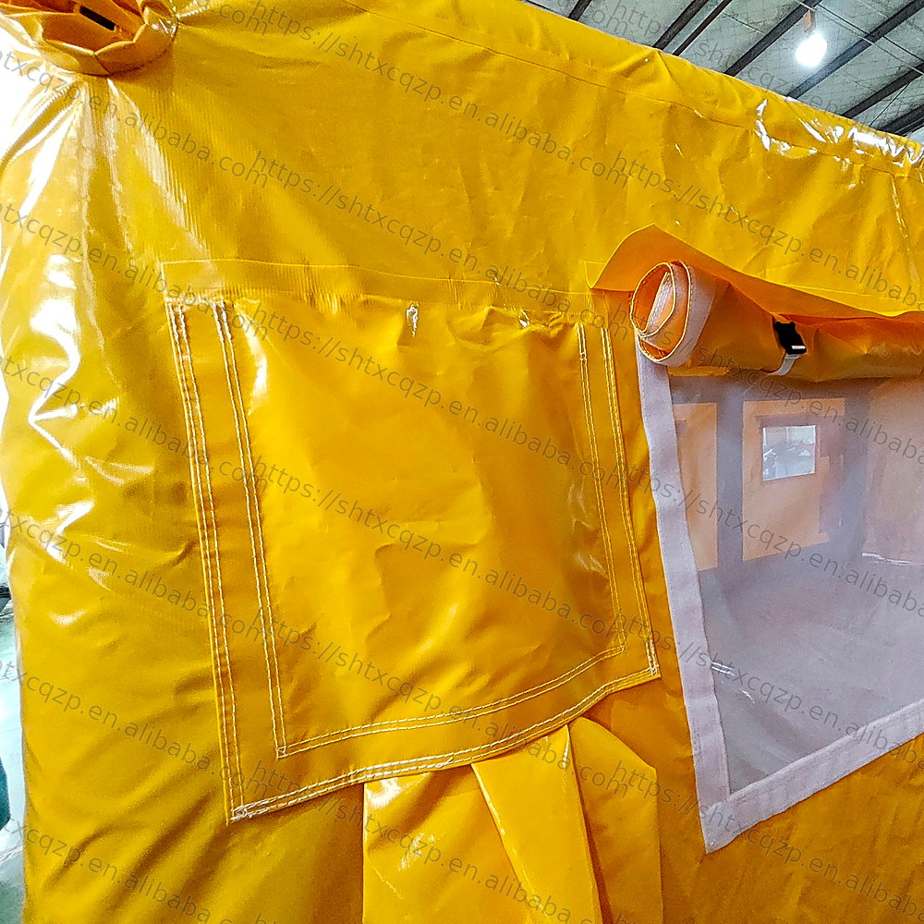  04 Window Cover Detail

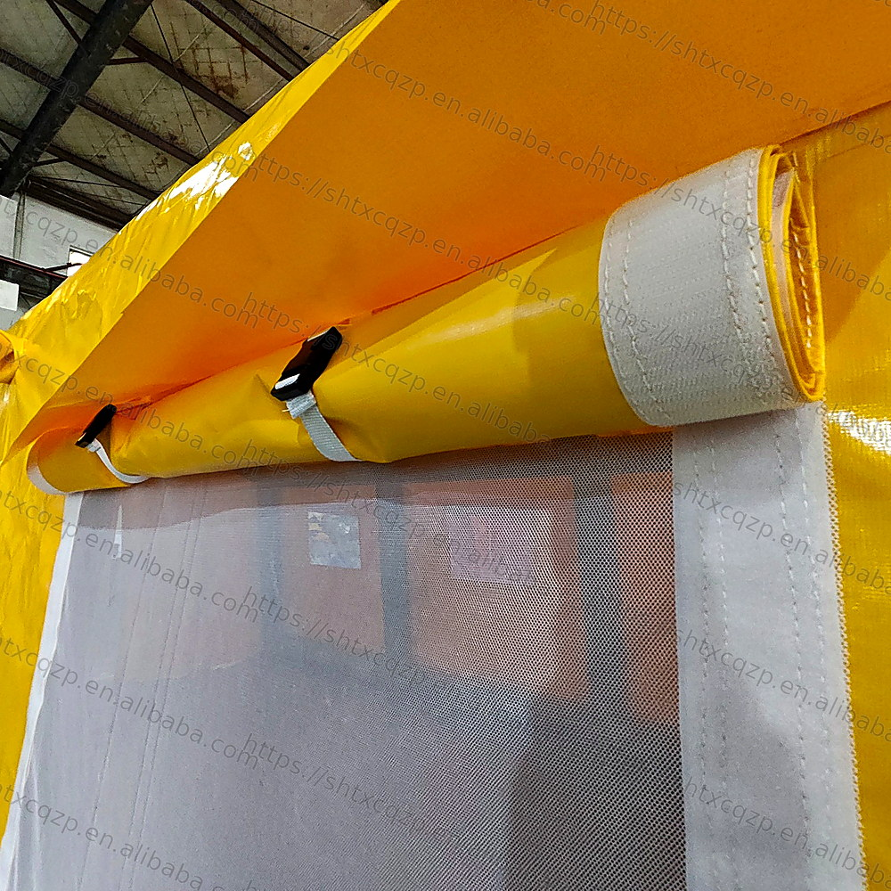  05 Roll Up Window Detail | 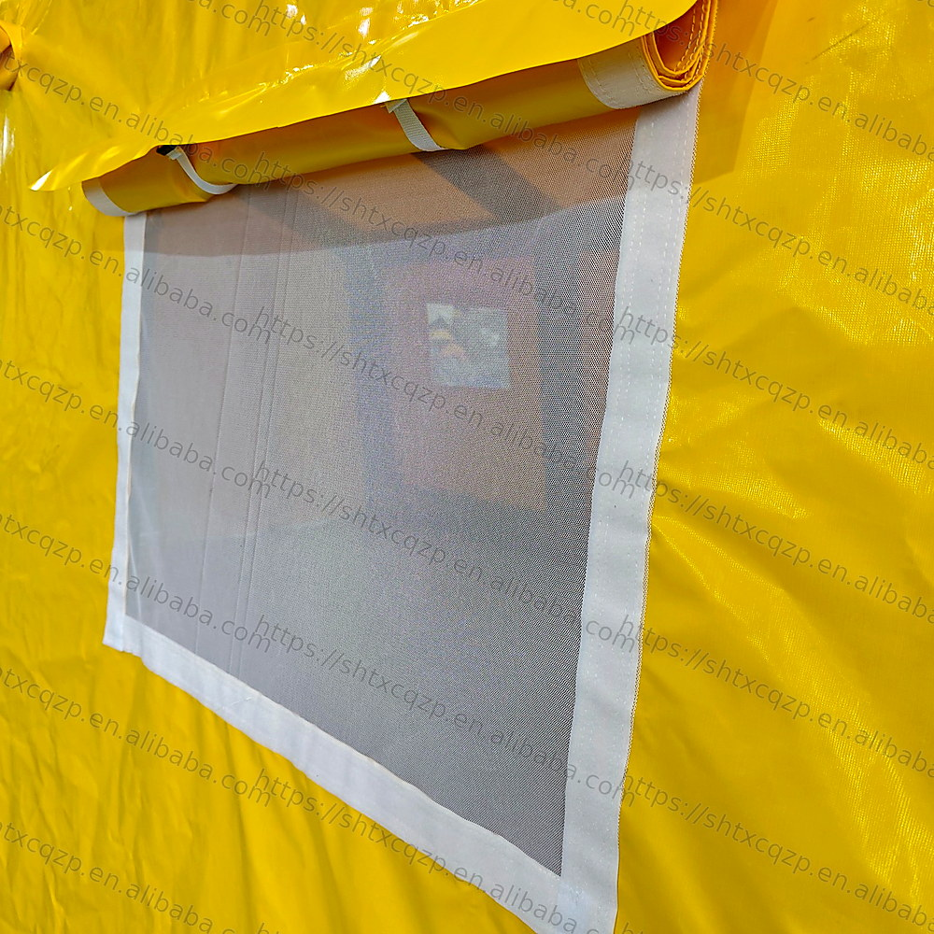  06 Mesh Window Detail

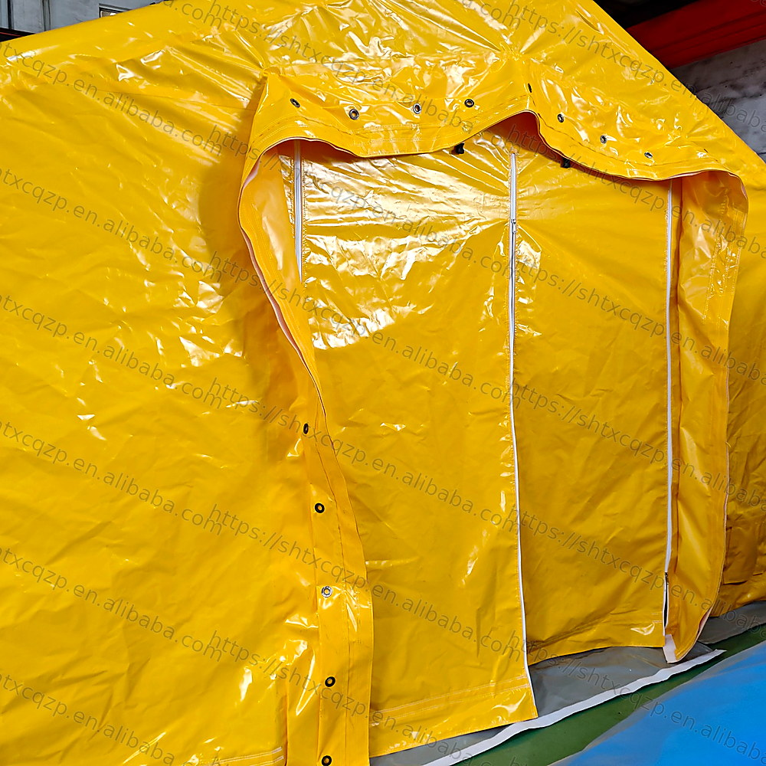  07 Entrance Door Detail | 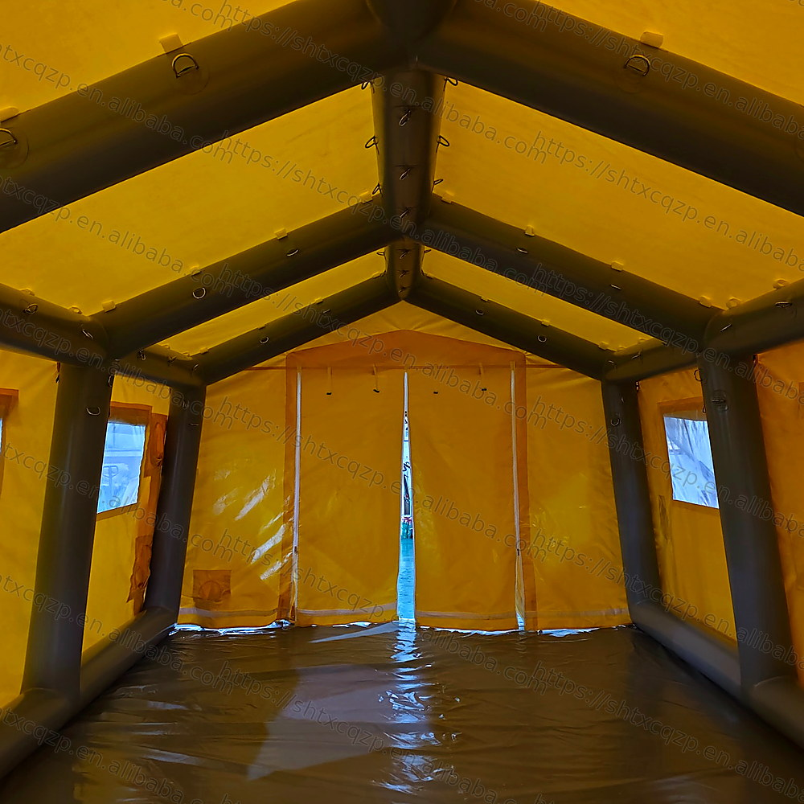  08 Interior Frame

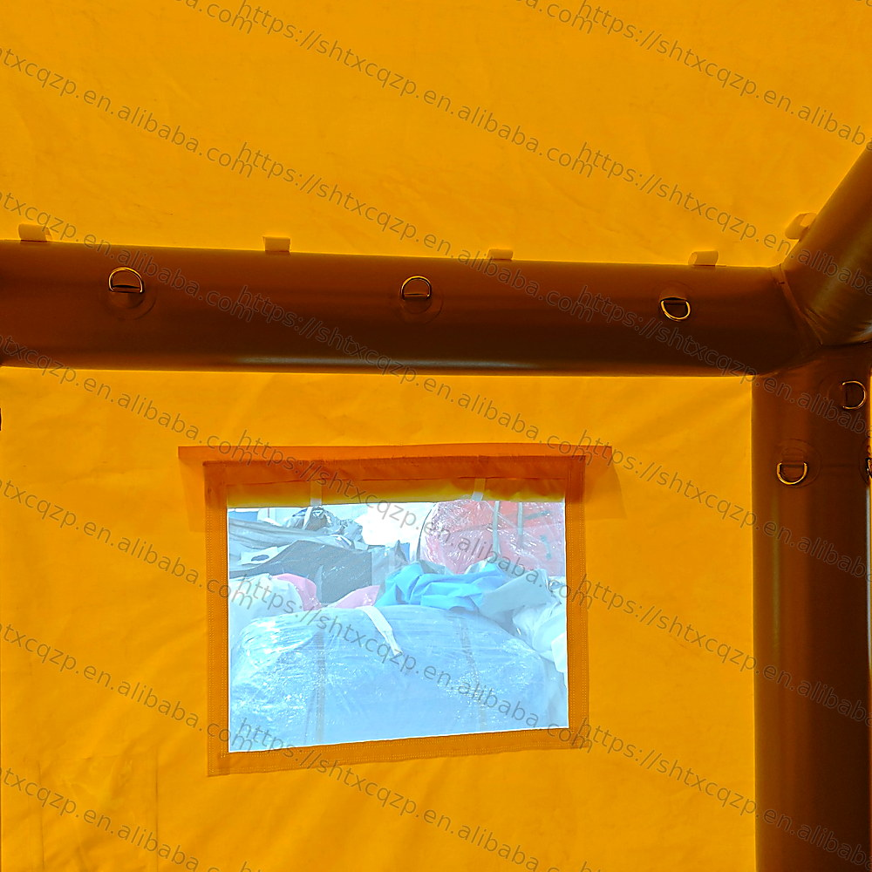  09 Interior Window | 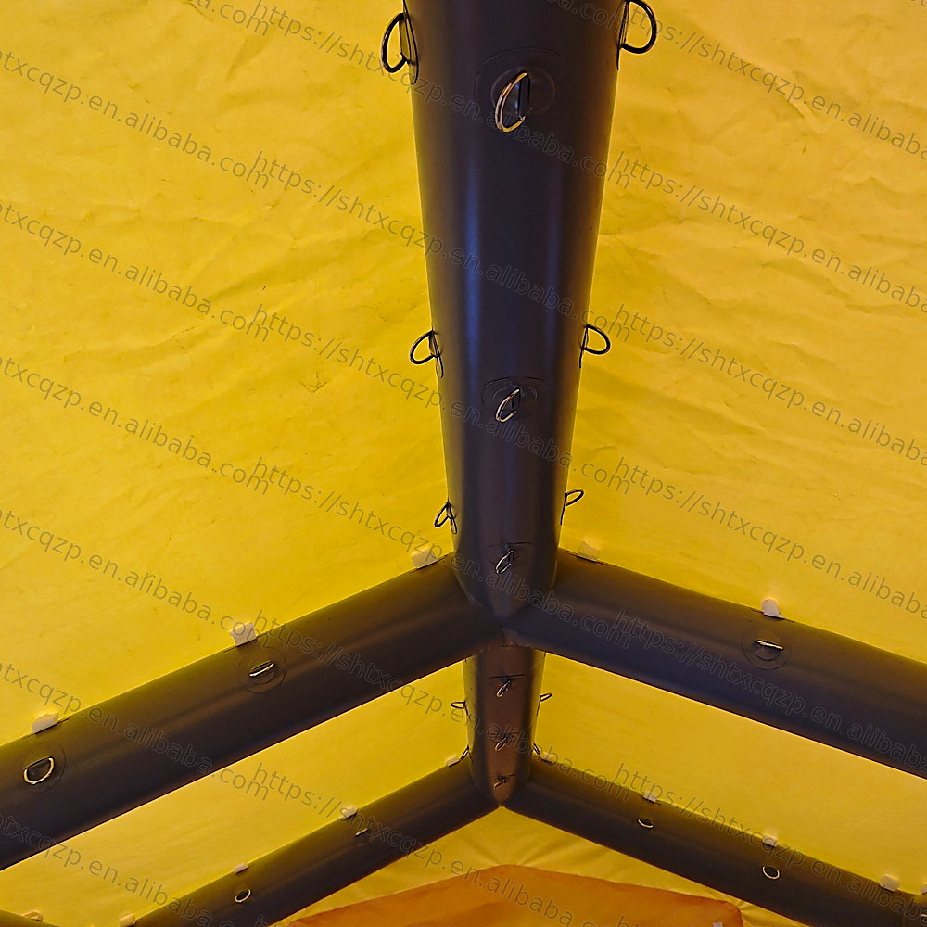  10 Inflatable Beam Detail

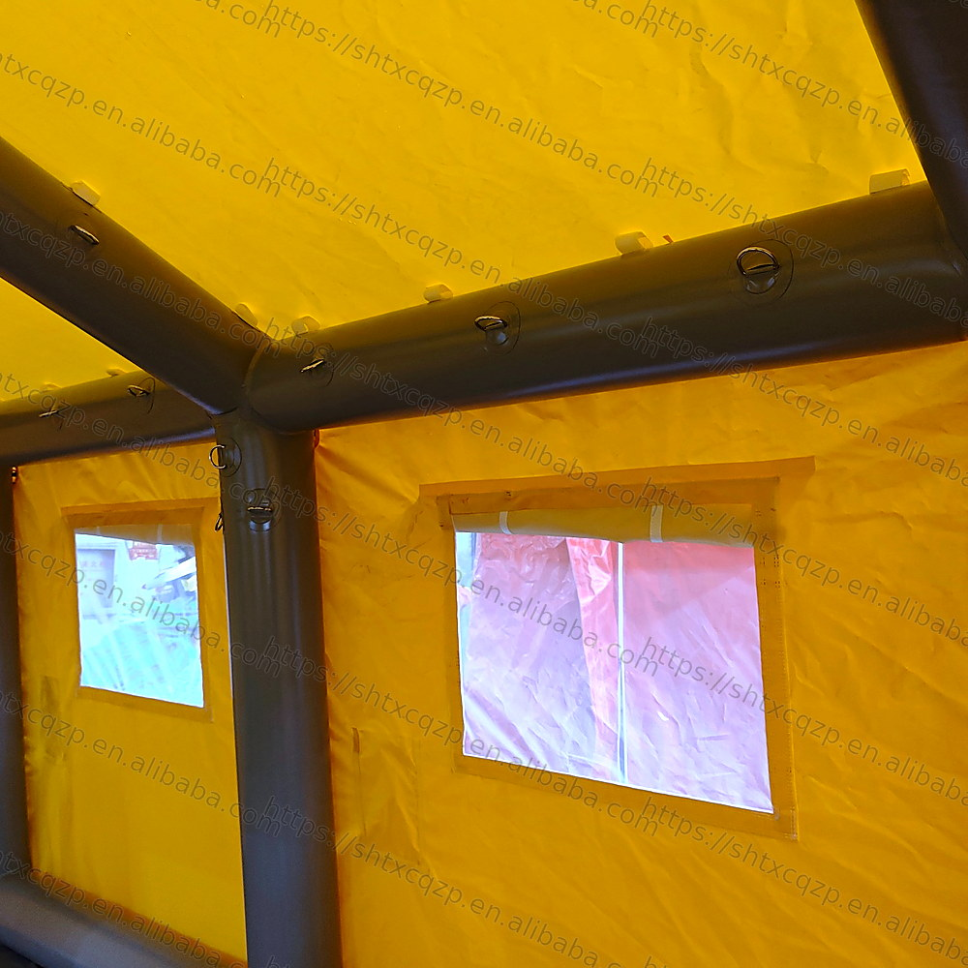
11 Interior Side View

3. Manufacturing Process
Project Design & Layout Confirmation: The tent structure, dimensions, window positions, door quantity, air-beam layout, ventilation design and optional partitions are confirmed according to the client’s usage scenario.
Material Selection & Inspection: Commercial-grade inflatable fabric is selected for abrasion resistance, waterproof performance, easy cleaning and long service life. The fabric surface, thickness, coating and color are checked before production.
Digital Pattern Making & Cutting: The production team prepares accurate cutting patterns based on the approved design. CNC cutting or manual precision cutting is used to keep panel size consistent and reduce material waste.
High-Frequency / Hot-Air Welding: Main inflatable tubes and large tarpaulin panels are welded to improve air tightness and water resistance. Welding lines are checked to ensure stable bonding and clean edges.
Sewing & Accessory Assembly: Windows, mesh panels, zipper doors, hook-and-loop fasteners, buckle straps, D-rings, valve covers and reinforcement patches are assembled according to the design.
Inflation Test & Detail Inspection: The finished tent is inflated for inspection. Workers check the air frame, seams, valves, window covers, door operation, anchoring points and overall appearance before packing.
Cleaning, Folding & Packing: After testing, the tent is cleaned, folded and packed with accessories. The packing method is designed for international shipping and convenient on-site installation.

4. Key Construction Details
• Reinforced inflatable air-beam frame: grey internal beams support the roof and side walls without heavy metal frames, making the tent faster to deploy and easier to transport.
• Durable outer cover: the glossy yellow tarpaulin surface is waterproof, easy to clean and suitable for temporary medical response environments.
• Roll-up ventilation windows: transparent mesh windows help improve air circulation while keeping the interior bright and visible.
• Secure entrance system: zipper doors, button holes, protective flaps and reinforced edges help improve sealing, privacy and daily operation stability.
• Multiple D-rings and fixing points: interior and exterior rings allow ropes, straps, lighting, partitions or other accessories to be fixed based on project requirements.
• Reinforced seams and corners: high-stress areas such as door edges, window borders, beam joints and bottom edges are strengthened to improve durability.

5. Advantages for Medical & Emergency Projects
Fast Deployment | Flexible Layout | Easy Maintenance
The inflatable frame can be set up quickly with an air blower, reducing installation time during emergency operations. | Custom sizes, doors, windows, inner partitions and functional areas can be designed for triage, treatment, storage or command use. | The waterproof fabric surface is easy to wipe, clean and store after use, helping rental companies and rescue teams improve turnaround efficiency.

6. Application Scenarios
• Emergency triage and first-aid station
• Temporary medical clinic or field hospital support
• Disaster relief, rescue command and outdoor medical response
• Quarantine, isolation and health screening area
• Event medical support, sports first-aid center and public safety projects
• Military, training, simulation and temporary logistics support areas

7. Customization Options
We support OEM/ODM customization for different project requirements. Available options include tent size, fabric thickness, color, printed logo, window quantity, door style, removable partitions, floor design, air blower configuration, connection corridor, lighting system, HVAC duct opening, package label and complete project solutions.

8. Quality Control Before Shipment
• Material surface check and color confirmation
• Welding seam inspection and reinforcement check
• Inflation and air-leakage inspection
• Door, zipper, buckle, window cover and valve function testing
• Appearance cleaning, folding check and accessory list confirmation

9. Inquiry Text for Buyers
Please send us your required tent size, application scenario, quantity, logo design and delivery destination. Our team can provide customized design, material recommendations, production details and a complete inflatable medical tent solution for your project.

